# CS 255 System Design Document Template

## UML Diagrams

### UML Use Case Diagram

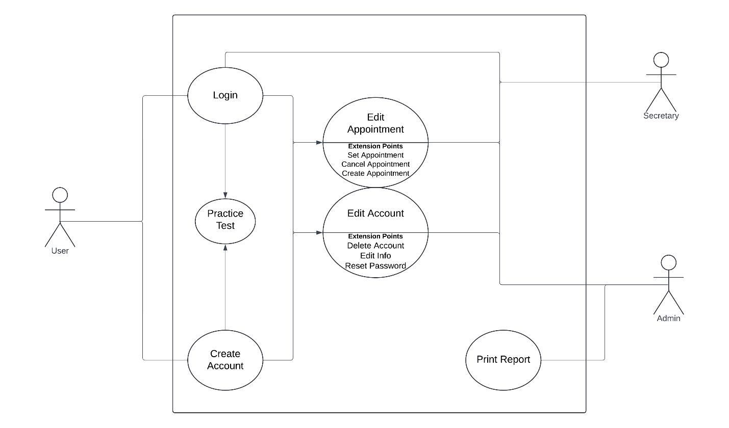

### UML Activity Diagrams

Edit Appointments Activity Diagram

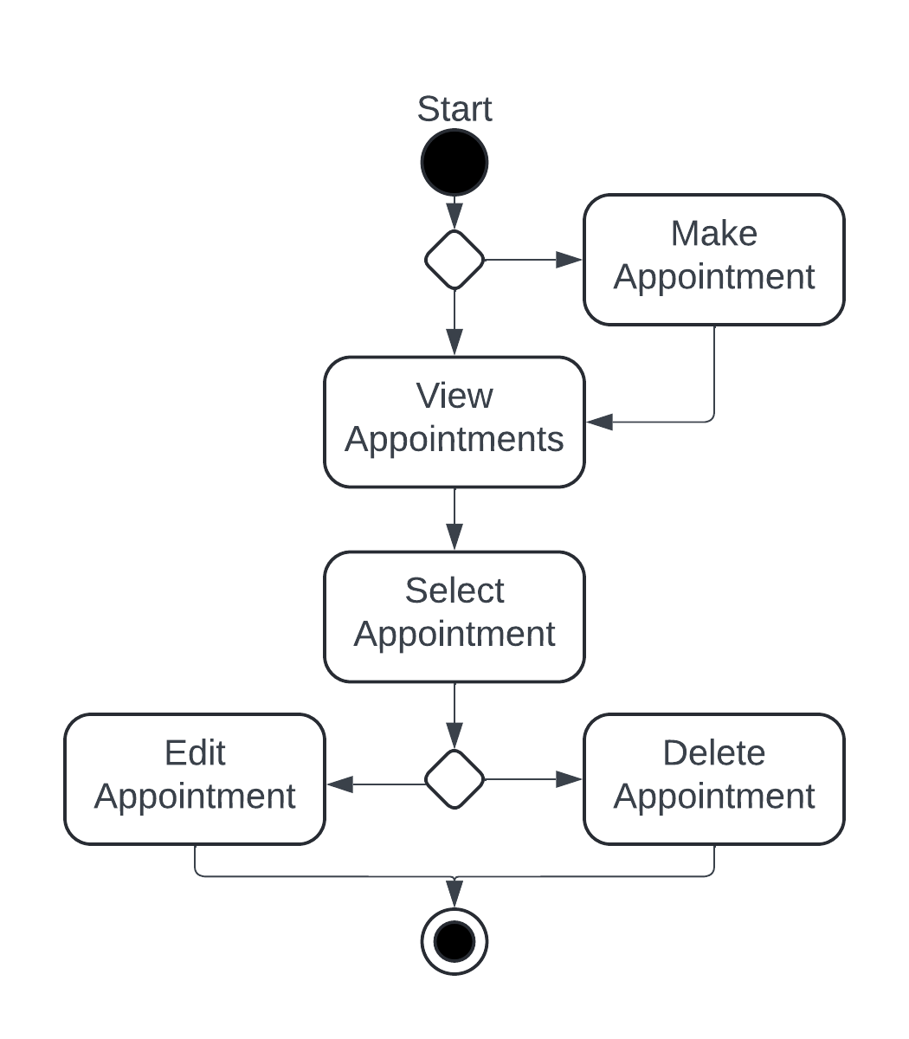

Create Account Activity Diagram

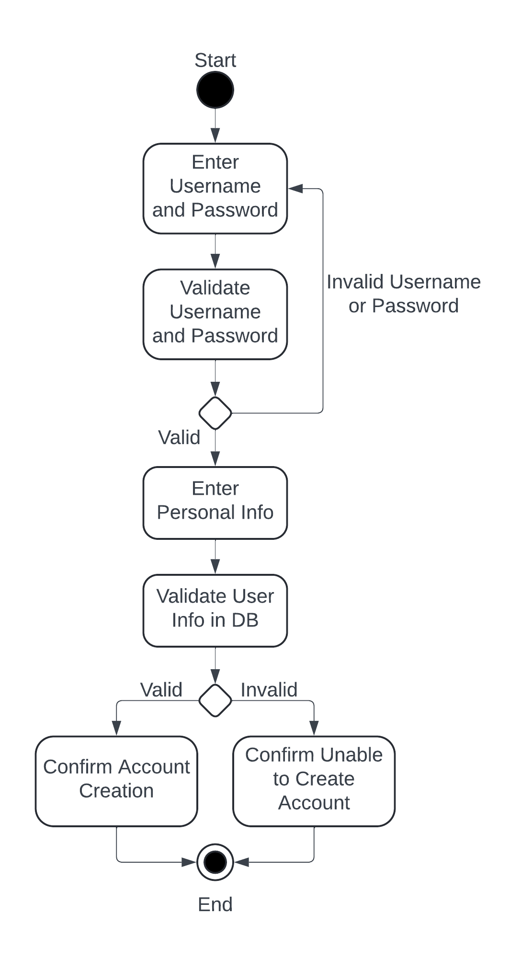

### UML Sequence Diagram

Create Account Sequence Diagram

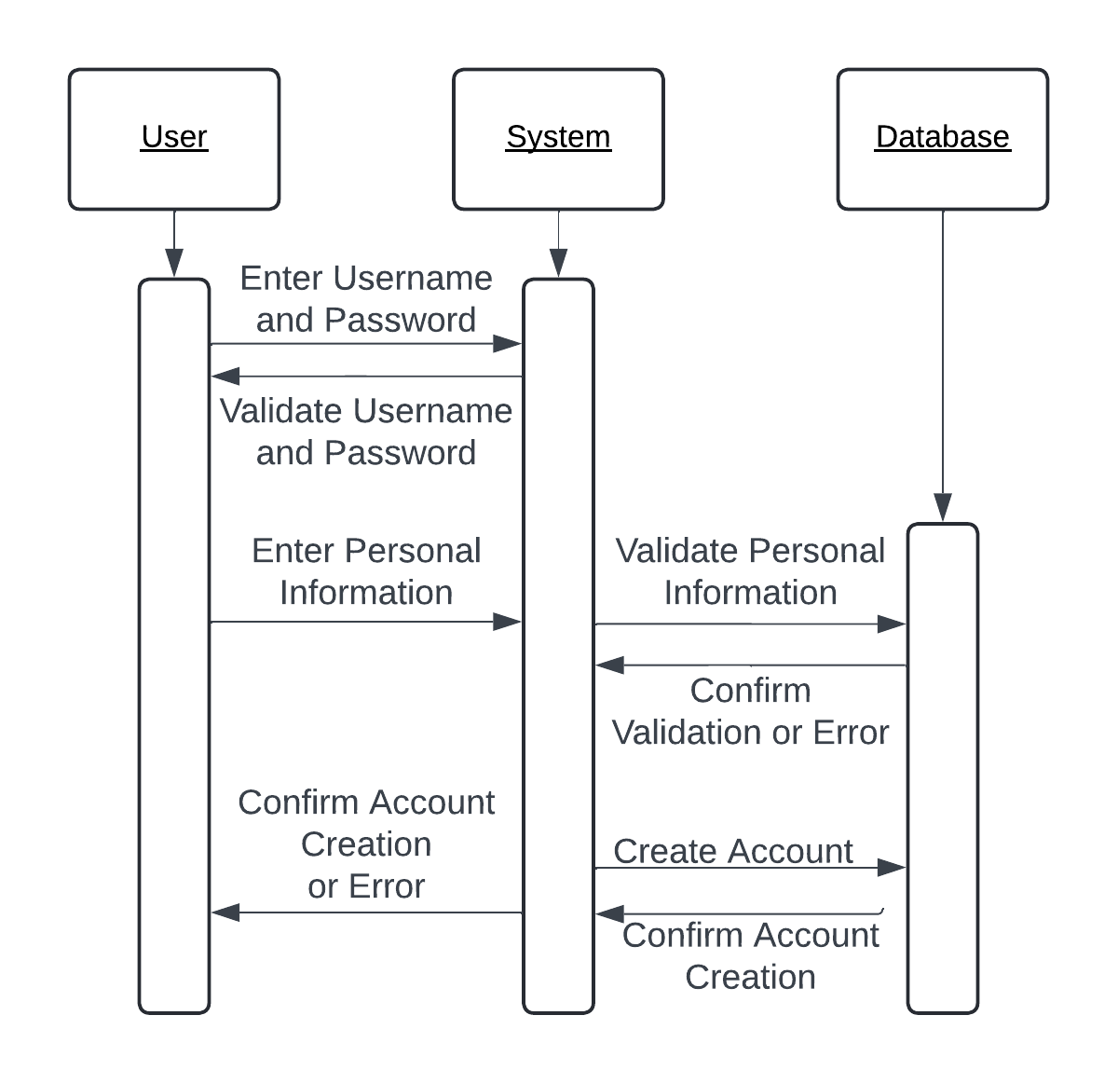

### UML Class Diagram

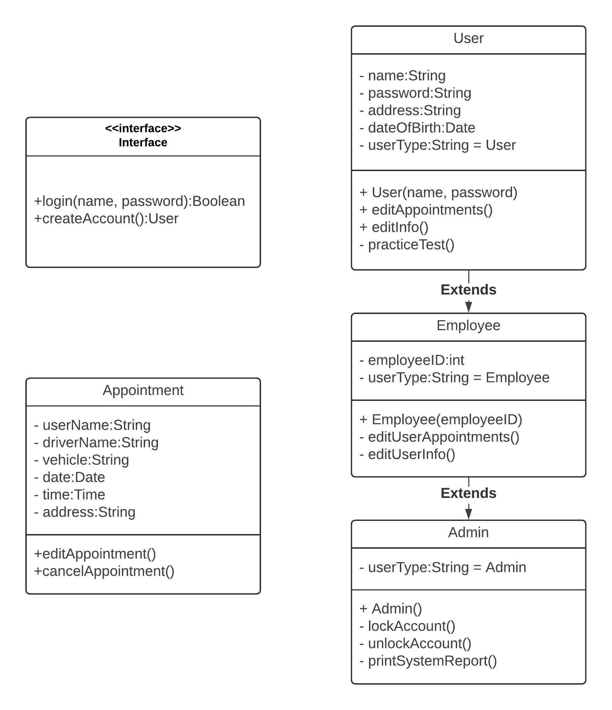

## Technical Requirements

For users to uses the system, they will need a computer with a browser and access to the internet. The system will be hosted on a cloud server that is accessed as a website. The cloud server should be handled by a third party as far as maintaining and expanding the system goes.